|  |  |  |  |
| --- | --- | --- | --- |
| VIIT Pune (@viit_pune) | Twitter | Bansilal Ramnath Agarwal Charitable Trust's  Vishwakarma Institute of Information Technology  **Department of**  **Artificial Intelligence and Data Science** | | |
| Student Name: Saikumar Padmawar | | | |
| Class: TY | Division: A | | Roll No: 371048 |
| Semester: 5 | | Academic Year: 2022-23 | |
| Subject Name & Code: ADUA31203: Cloud Computing & Analytics Networks | | | |
| Title of Assignment: Study of Cloud Computing & Architecture | | | |
| Date of Performance:22/08/2022 | | Date of Submission: 22/08/2022 | |

**Assignment-1**

**Aim:** Study of Cloud Computing & Architecture

**Problem Statement:** To study cloud computing and its architecture

**Background Information:**

**Cloud computing:**

cloud computing is the delivery of computing services—including servers, storage, databases, networking, software, analytics, and intelligence—over the Internet (“the cloud”) to offer faster innovation, flexible resources, and economies of scale.

**Types of cloud computing:**

***1)Public cloud:***

Public clouds are owned and operated by a third-party [cloud service providers](https://azure.microsoft.com/en-us/overview/choosing-a-cloud-service-provider/), which deliver their computing resources, like servers and storage, over the Internet.

***2)Private cloud:***

A private cloud refers to cloud computing resources used exclusively by a single business or organization. A private cloud can be physically located on the company’s on-site datacentre. Some companies also pay third-party service providers to host their private cloud. A private cloud is one in which the services and infrastructure are maintained on a private network.

***3)Hybrid cloud***

Hybrid clouds combine public and private clouds, bound together by technology that allows data and applications to be shared between them. By allowing data and applications to move between private and public clouds, a hybrid cloud gives your business greater flexibility, more deployment options, and helps optimize your existing infrastructure, security, and compliance.

**Types of cloud services:**

1. ***Infrastructure as a service (IaaS)***

The most basic category of cloud computing services. With IaaS, you rent IT infrastructure—servers and virtual machines (VMs), storage, networks, operating systems—from a cloud provider on a pay-as-you-go basis.

**Example:** Amazon Web Services (AWS) EC2, Google Compute Engine (GCE), Cisco Metapod.

1. ***Platform as a service (PaaS)***

Platform as a service refers to cloud computing services that supply an on-demand environment for developing, testing, delivering, and managing software applications. PaaS is designed to make it easier for developers to quickly create web or mobile apps, without worrying about setting up or managing the underlying infrastructure of servers, storage, network, and databases needed for development.

**Example:** Windows Azure, Force.com, Magento Commerce Cloud, OpenShift.

1. ***Serverless computing***

Overlapping with PaaS, serverless computing focuses on building app functionality without spending time continually managing the servers and infrastructure required to do so. The cloud provider handles the setup, capacity planning, and server management for you. Serverless architectures are highly scalable and event-driven, only using resources when a specific function or trigger occurs.

1. ***Software as a service (SaaS)***

Software as a service is a method for delivering software applications over the Internet, on demand and typically on a subscription basis. With SaaS, cloud providers host and manage the software application and underlying infrastructure, and handle any maintenance, like software upgrades and security patching. Users connect to the application over the Internet, usually with a web browser on their phone, tablet, or PC.

**Example:** Google Apps, Salesforce Dropbox, Slack, Hubspot, Cisco WebEx.

**Cloud computing architecture:**

Cloud computing architecture is a combination of service-oriented architecture and event-driven architecture. Architecture of cloud computing is the combination of both [SOA (Service Oriented Architecture)](https://www.geeksforgeeks.org/service-oriented-architecture/) and EDA (Event Driven Architecture). Client infrastructure, application, service, runtime cloud, storage, infrastructure, management, and security all these are the components of cloud computing architecture.

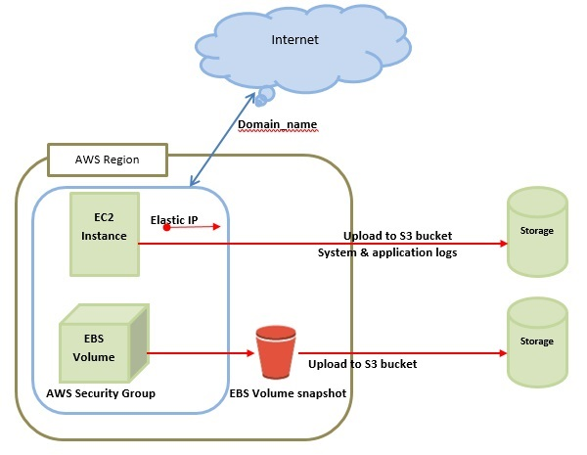

Cloud computing architecture is divided into the following two parts -

* Front End
* Back End

The below diagram shows the architecture of cloud computing -

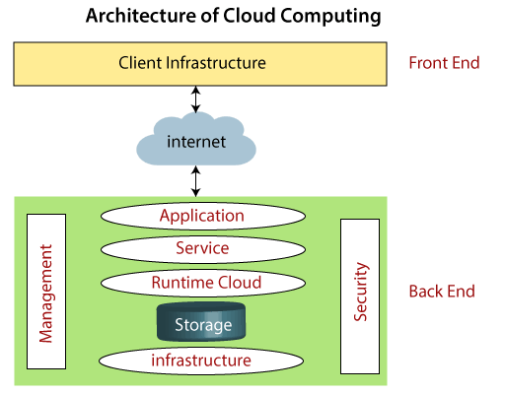

* **Front End**

The front end is used by the client. It contains client-side interfaces and applications that are required to access the cloud computing platforms. The front end includes web servers (including Chrome, Firefox, internet explorer, etc.), thin & fat clients, tablets, and mobile devices.

* **Back End**

The back end is used by the service provider. It manages all the resources that are required to provide cloud computing services. It includes a huge amount of data storage, security mechanism, virtual machines, deploying models, servers, traffic control mechanisms, etc.

**Components of Cloud Computing Architecture**

There are the following components of cloud computing architecture -

**1. Client Infrastructure**

Client Infrastructure is a Front-end component. It provides GUI (Graphical User Interface) to interact with the cloud.

**2. Application**

The application may be any software or platform that a client wants to access.

**3. Service**

A Cloud Services manages that which type of service you access according to the client’s requirement.

Cloud computing offers the following three type of services:

**i. Software as a Service (SaaS)**

**ii. Platform as a Service (PaaS)**

**iii. Infrastructure as a Service (IaaS)**

**4. Runtime Cloud**

Runtime Cloud provides the execution and runtime environment to the virtual machines.

**5. Storage**

Storage is one of the most important components of cloud computing. It provides a huge amount of storage capacity in the cloud to store and manage data.

**6. Infrastructure**

It provides services on the host level, application level, and network level. Cloud infrastructure includes hardware and software components such as servers, storage, network devices, virtualization software, and other storage resources that are needed to support the cloud computing model.

**7. Management**

Management is used to manage components such as application, service, runtime cloud, storage, infrastructure, and other security issues in the backend and establish coordination between them.

**8. Security**

Security is an in-built back-end component of cloud computing. It implements a security mechanism in the back end.

**9. Internet**

The Internet is medium through which front end and back end can interact and communicate with each other.

**Resource Components:**

1.IAM- IAM is a cloud service that controls the permissions and access for users and cloud resources. IAM policies are sets of permission policies that can be attached to either users or cloud resources to authorize what they access and what they can do with it.

2.EC2- Amazon Elastic Compute Cloud (Amazon EC2) provides scalable computing capacity in the Amazon Web Services (AWS) Cloud. Using Amazon EC2 eliminates your need to invest in hardware up front, so you can develop and deploy applications faster.

3.VPN- A cloud virtual private network (cloud VPN) is a form of technology designed to help users access their organization's applications, data, and files through a website or an application. Unlike traditional or static VPNs, a cloud VPN provides a secure connection that can be rapidly deployed globally.

4.Security Groups- A security group is an AWS firewall solution that performs one primary function: to filter incoming and outgoing traffic from an EC2 instance. It accomplishes this filtering function at the TCP and IP layers, via their respective ports, and source/destination IP addresses.

5.Lambda Function: - Lambda runs your code on high availability compute infrastructure and performs all the administration of your computer resources. This includes server and operating system maintenance, capacity provisioning and automatic scaling, code and security patch deployment, and code monitoring and logging.

3.Billing Information

The AWS Billing console allows you to easily understand your AWS spending, view and pay invoices, manage billing preferences, and tax settings, and access additional Cloud Financial Management services. Quickly evaluate whether your monthly spend is in line with prior periods, forecast, or budget, and investigate and take corrective actions in a timely manner. The AWS Bills page provides a monthly view of your chargeable costs. For monthly billing periods that have not yet closed, the Bills page will display the most recent estimated charges based on services metered to date. Invoices are generated when a monthly billing period closes, or when subscriptions or one-time purchases are made

**Cloud Resource Requirements:**

Aws cloud root login

1. Go to <https://aws.amazon.com/console/>
2. Click on create an AWS account

1. Login

**Conclusion:**